**Vodafone USB Modem K3770**

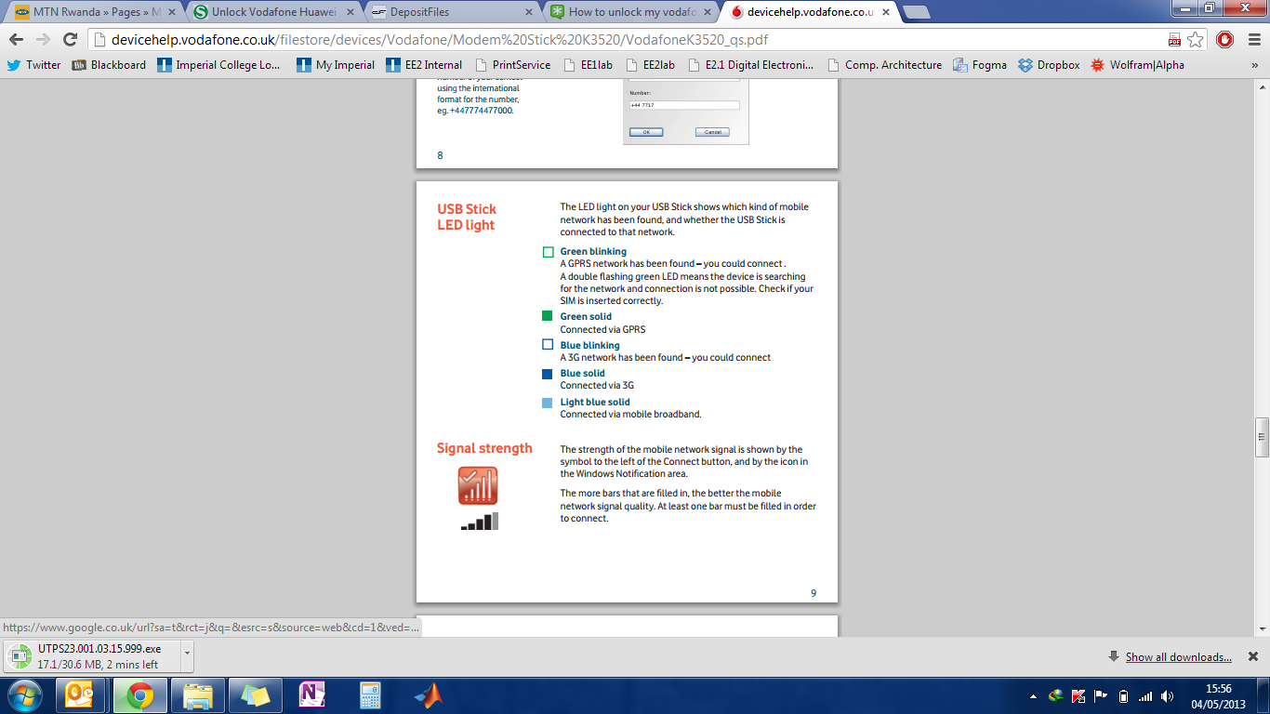

**Code 🡪 Fetching a page**

#include "mbed.h"

#include "VodafoneUSBModem.h"

#include "HTTPClient.h"

DigitalOut myled(LED1);

Serial pc(USBTX, USBRX);

This needs to be changed to the sim card apn

int main()

{

VodafoneUSBModem modem;

HTTPClient http;

char str[512];

int ret = modem.connect("mobile.o2.co.uk"); //pp.vodafone.co.uk");

if(ret)

{

pc.printf("Could not connect\n");

return;

}

//GET data

pc.printf("Trying to fetch page...\r\n");

ret = http.get("http://mbed.org/media/uploads/donatien/hello.txt", str, 128);

if (!ret)

{

pc.printf("Page fetched successfully - read %d characters \r\n", strlen(str));

pc.printf("Result: %s\r\n", str);

}

else

{

pc.printf("Error - ret = %d - HTTP return code = %d \r\n", ret, http.getHTTPResponseCode());

}

modem.disconnect();

}

**Unlocking the Vodafone USB Modem K3770**

This site has the details: <http://modemunlock4u.blogspot.co.uk/2013/01/unlock-vodafone-huawei-modem-k3770.html>

Firstly, find the IMEI number of your device and note it down. It will be required later.

NB: The IMEI number is located near to where the sim card should go for the K3770.

In case it has moved or cannot be found. Follow these instructions (to be done on a Windows PC):

1. Install the original Vodafone software that came with the USB Modem.
2. Download the latest Huawei Dashboard from <http://adf.ly/9jI7d> or <http://adf.ly/9jI9j>. Alternatively, it can be found \Dropbox\e.quinox Data Logger\Datalogging 2012-2013\USB MODEM\UnlockVodafone.zip\ UTPS23.001.03.15.999.exe
3. Install the Dashboard (UTPS23.001.03.15.999.exe)
4. This will change the dashboard of the device. Note: changing the dashboard automatically terminates your warranty with the operator.
5. Wait for the drivers to install and Run the new software (It will be called Mobile Broadband and will have a greed icon on the desktop if it is there)
6. Download universal master code from here [http://adf.ly/9jI27](http://adf.ly/9jI27%20) or [http://adf.ly/9jI43](http://adf.ly/9jI43%20) and run. Alternatively, it can be found \Dropbox\e.quinox Data Logger\Datalogging 2012-2013\USB MODEM\UnlockVodafone.zip\Universal_MasterCode.exe
7. Run the program Universal_MasterCode.exe.
8. Switch to the Huawei Tab and type in your IMEI number and click Calculate.
9. Copy the Unlock Code.
10. Insert a new Sim card into the modem and open the dashboard i.e. Mobile Broadband which will have a greed icon on the desktop if it is there.
11. It should ask you for the unlock code. Enter the unlock code and the device will be unlocked.

